Objectives: Students will be able to create and graph linear functions in all three forms:
y- intercept, point slope and standard form. Students will be able to create functions parallel or perpendicular to some given lines.
Standards:
A2.F.BF.A.1 Write a function that describes a relationship between two quantities.
A2.F.BF.A.1a Determine an explicit expression, a recursive process, or steps for calculation from a context.
A2.F.BF.A.1b Combine standard function types using arithmetic operations.
2-4 More Linear Functions
Warm up
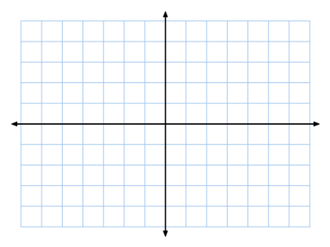
Graph a function -2x + 3y = 6. Write it in y-intercept form then graph.

Vocabulary
______________________ - the slopes of these lines are equal.
_____________________________ - the slopes of these lines are negative reciprocals of each other.
Examples of negative reciprocals : 1/3 _____ -2/3 ______ -1 ______ 5 ______
Formulas
- point-slope form of a line is $y-y_{1}=m(x{-x}_{1})$
- standard form of a linear equation is $Ax+By=C$
- m =$-\frac{A}{B}$, y-intercept = $\frac{C}{B}$, x-intercept = $\frac{C}{A}$
Examples
- Write the equation of the line that passes through (-6, 2) with a slope of $\frac{2}{3}$.
a) y-intercept form b) point slope form c) standard form

- Write the equation of the line through (-3, 2) and (5, 8).
a) y-intercept form b) point slope form c) standard form

- Write the equation $y= \frac{3}{4}x-5$ in standard form. Use integer coefficients.

- What is the equation of the line in point-slope form?

- Find the x- and y-intercepts of $2x+3y=-12$.

- What is the equation of the line parallel to $y=2x-3$ through (1, -3) in slope-intercept form?

- What is the equation of the line perpendicular to $y= \frac{2}{3}x-1$ through (-2, 4) in slope-intercept form?

HOMEWORK!!! Complete your assignment on a separate sheet of paper. Show all Work
- Write an equation for each line in slope-intercept form
- slope = -3, through (1, -4) b. slope = $\frac{1}{2}$ , through (2, 3)

- What are the intercepts of $3x+y=6$? Graph the equation.

- If the intercepts of a line are (a, 0) and (0, b), what is the slope of the line?

- Write the equation of the line through (1, 9) and (6, 2) in point-slope form?

- Write an equation of each line in standard form with integer coefficients.
- $y=-7x-9$ b. $y=-\frac{3}{5}x+3$
- Write an equation for the line shown in standard form.

