**Standard-** [A2. F.BF.A.1](https://drive.google.com/file/d/0B7nJhvJFpsTjVGF2VURxMXVId2s/view#p15) Write a function that describes a relationship between two quantities.

**Objective**: *Students will discover different types of patterns and create functions that describe relationships between two quantities.*

* 1. **Patterns and Expressions**

**Warm up**



5. **THINK**: a snail is moving up the small tree 3 branches up during day time, and then it slides down 2 branches at night. After how many days will the snail reach the 10th branch?

**Key Concepts**

__________________ - a symbol, usually a letter, that represents one or more numbers.

_________________________________- a mathematical phrase that contains numbers and operation symbols.

______________________________- a mathematical phrase that contains one or more variables.

**Examples**

1. Look at the figures below. Do you see a pattern? What would be the next figure in the pattern?

1. What would be the 10th number in the pattern 4, 7, 10, 13, 16…? What is an expression that describes the number for the *n*th term?
2. Identify a pattern by making a table for the coordinates (1, 4), (2, 6), (3, 8), (4, 10). Then find the next coordinate.

|  |  |  |  |
| --- | --- | --- | --- |
|  | ***x*** | **rule** | ***y*** |
|  |  |  |  |
|  |  |  |  |
|  |  |  |  |
|  |  |  |  |
|  | **n** |  |  |

1. Identify a pattern by making a table of the inputs and outputs. Include a process column.
   1. 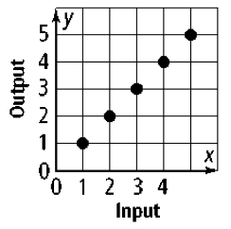 b)

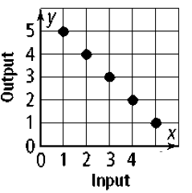

**Standard-**[A2. F.BF.A.1](https://drive.google.com/file/d/0B7nJhvJFpsTjVGF2VURxMXVId2s/view#p15) Write a function that describes a relationship between two quantities.

**Objective:***Students will organize numbers into corresponding real number subset, organize numbers in order from least to greatest on a number line, and identify properties of real numbers.*

* 1. **Properties of Real Numbers**

**Warm up**

Circle the greater number out of each pair of numbers: a) -5 or -4 b) 3/7 or 4/7 c) 3/4 or 2/3

**Key Concepts**

|  |  |  |
| --- | --- | --- |
| Subsets of the Real Numbers | Description | Examples |
| Natural Numbers (N) |  |  |
| Whole Numbers (W) |  |  |
| Integers (Z) |  |  |
| Rational Numbers (Q) |  |  |
| Irrational Numbers (I) |  |  |

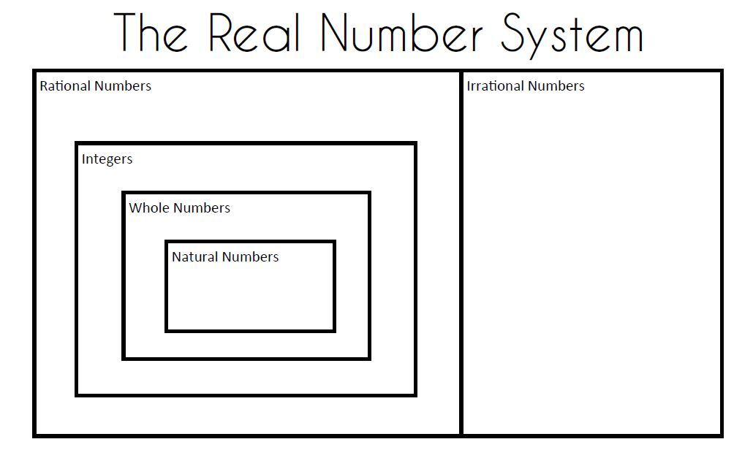

**THINK:** Are all natural numbers also rational? Are all whole numbers also integers?

Are all rational numbers integers? Are there any real numbers that are both rational and irrational?

|  |  |  |
| --- | --- | --- |
| **Property** | **Addition** | **Multiplication** |
|  |  |  |
| Closure | *a* + *b* is a real number | *ab* is a real number |
| Commutative | *a* + *b* = *b* + *a* | *ab* = *ba* |
| Associative | (*a* + *b*) + *c* = *a* + (*b* + *c*) | (*ab*)*c* = *a*(*bc*) |
| Identity | 0 is the additive identity | 1 is the multiplicative identity |
|  | *a* + 0 = *a* | *a*•1 = *a* |
| Inverse | *a* + -*a* = 0 | *a* • (1/*a*) =1, *a* ≠ 0 |
| Distributive | *a*( *b* + *c*) = *ab* + *ac* |  |

**Examples**

1. Graph the numbers $-4,\frac{3}{2}, \sqrt{5}, -\frac{12}{5}, π$
2. Which set of numbers bests describes a person’s age?
3. Which set of number best describes the amount of money in a bank account?
4. Name the property
5. $\left(\frac{2}{3}\right)\left(\frac{3}{2}\right)=1$**b**. (3 $∙$ 4) $∙$ 5 = (4 $∙$ 3) $∙$ 5 **c**. *x* + (*y* + *z*) = (*x* + *y*) + *z*

**Standard:** [A2. F.BF.A.1](https://drive.google.com/file/d/0B7nJhvJFpsTjVGF2VURxMXVId2s/view#p15) Write a function that describes a relationship between two quantities.

**Objective:** *Students will model phrases and situations using algebraic expressions, and evaluate them.*

**1-3 Algebraic Expressions**

**Warm up: a)** write 20% as a decimal and as a fraction b) simplify -5-2*2 - (-11) -2 =

**Key Concepts**

__________________ - an expression that is a number, a variable, or the product of a number and one or more variables

______________________- the numerical factor of a term

______________________________- a term with no variable

_____________________- the same variables raised to the same power

**Examples**

1. Write the algebraic expression for the phrases.
2. Seven fewer than ***t* __________**
3. Two times the sum of ***a*** and 5 __________
4. Four more than three times the difference of ***x*** and 12 __________
5. Model the situation using an algebraic expression.
6. A job pays $12.50 per hour and 20% commission. __________
7. Your allowance is $150 per month and you spend $3 a day. __________
8. You are hosting a party and decide to buy pizza, chips and drinks. Each pizza costs $5, each bag of chips costs $3.50 and each 2-Liter drink costs $1.25. Write an algebraic expression that models the situation and determine the total cost to purchase 3 pizzas, 2 bags of chips and 4 drinks.
9. Simplify by combining like terms.

$4x^{2}+5x-12x^{2}-3+x$

$-1+3x-4x+x^{2}-2$

$3\left(a+4\right)-x+2(x-4)$
10. ______________________________
11. ______________________________
12. ______________________________
13. Evaluate the expression 6*c* + 5*d* - 4*c* - 3*d* + 3*c* - 6*d*; for the given values of the variables

*c* = 4 and *d* = -2

**Standards:** [A2. F.BF.A.1](https://drive.google.com/file/d/0B7nJhvJFpsTjVGF2VURxMXVId2s/view#p15) Write a function that describes a relationship between two quantities.

A2.A.CED.A.2Rearrange formulas to highlight a quantity of interest.

**Objectves:** *Students will create and solve linear equations and solve a literal equation for the given variable*

**1-4 Solving Equations**

**Warm up**

Use order of operations to simplify.



**Key Concepts**

|  |  |
| --- | --- |
| **Property** | **Definition** |
| Reflexive |  |
| Symmetric |  |
| Transitive |  |
| Substitution |  |
| Addition/ Subtraction |  |
| Multiplication/ Division |  |

___________________- an equation that is true for every value of the variable.

________________________________- an equation that uses at least 2 letters as variables. You can solve for any variable “in terms of” the other variables.

**Examples**

1. Solve the one-step equations.
2. $w-2=10$ b. $\frac{y}{4}= -3$
3. Solve the two-step equations.
4. $-4z+1=26$ b. $\frac{2}{3}x-2=10$
5. Solve the multi-step equations.
6. $3\left(2x-1\right)=11x$ b. $-6y+27=3(y-3)$
7. Determine whether the equations are always true, sometimes true or never true.
8. $11+3-7=6x+5-3x$ b. $6x+5-2x=4+4x-1$
9. Solve the literal equations.
10. $d=rt$ for $r$ b. $C=\frac{5}{9}(F-32)$ for $F$
11. The cost to rent a moving truck is $75 plus $58 per hour. If Keisha paid $336 to rent the truck, how many hours did she rent the truck?
12. Avery charges $10 to babysit one child and $3.50 for each additional child. If Avery earned $37.50, how many children did she babysit?

**Standard:** [A2. F.BF.A.1](https://drive.google.com/file/d/0B7nJhvJFpsTjVGF2VURxMXVId2s/view#p15) Write a function that describes a relationship between two quantities.

**Objective*:*** *Students will model and solve inequalities, and represent solutions using graph (number line) and interval notation.*

**1-5 Solving inequalities**

**Warm up** Solve each equation.



**Key Concepts** Writing and graphing inequalities

|  |  |  |
| --- | --- | --- |
| x > 4 | *x* is greater than 4 |  |
| x ≥ 4 | *x* is greater than or equal to 4 |  |
| x < 4 | *x* is less than 4 |  |
| x ≤ 4 | *x* is less than or equal to 4 |  |

**Examples**

1. Write an inequality that represents the sentence.
2. Two fewer than a number is at most ten. __________________________
3. The quotient of a number and 5 is no more than 14. _________________
4. A person must be at least 48 inches to ride. ________________________
5. Graph the inequalities

a. $n≤5$

$x>-2$

$4≤a$

3. Solve the inequality and graph the solution.
4. $2x+6>13$ b. $-3\left(2x-5\right)+1 ≤4$
5. A music download service has two subscription plans. The first plan has a $9 membership fee and then charges $1 per download. The second plan charges a $25 membership fee and $.50 per download. How many songs must you download for the second plan to cost less than the first plan?
6. Is the inequality, always, sometimes or never true?
7. $-2\left(3x+1\right)>-6x+7$ b. $5\left(2x-3\right)-7x ≤3x+8$
8. Solve the compound inequality and graph $7<2x+1$ and $3x≤18$.
9. Solve the compound inequality and graph $7+k≥6$ or $8+k<3$.
10. Solve the compound inequality and graph $-6≤2x-4≤12$
11. Write the solution set as a graph and as an interval. Then write it using **set notation**.

$n≤-3$

$-1≤n≤5$

$x>2$

$x>0 and x≤6$

$x≤-3 or x≥-2$
12. ______________
13. ______________

1. ______________
2. ______________

1. ______________

**Standard:** [A2. F.BF.A.1](https://drive.google.com/file/d/0B7nJhvJFpsTjVGF2VURxMXVId2s/view#p15) Write a function that describes a relationship between two quantities.

**Objective:** *Students will model and solve absolute value equations and graph the solutions on the number line.*

* 1. **Absolute Value Equations and Inequalities**

Warm up State whether the inequality is true or false.

1) 5 < 12 2) 5 < -12 3) 5 ≥ 5

**Key Concepts**

______________________________ - the distance from zero on the number line. Written |x|

__________________________________- a solution derived from an original equation that is NOT a solution to the original equation.

**Steps to solve an absolute value equation**

1. 3.

2. 4.

**Examples**

1. Solve and check the absolute value equation.
2. $\left|2x-1\right|=5$ b. $3\left|x+2\right|-1=8$
3. Solve and check for extraneous solutions.
$\left|3x+2\right|=4x+5$

4. Solve and graph the inequality.
5. $\left|2x-1\right|+1<5$ b. $\left|2x+4\right|≥6$
6. Solve and graph the inequality.
7. $\left|\frac{x-3}{2}\right|+2<6$ b. $\frac{2}{3}|6x-2|≥4$