Guided Notes

Chapter 2
Functions, Equations, and Graphs

Unit Essential Questions
Does it matter which form of a linear equation that you use?

How do you use transformations to help graph absolute value functions?

How can you model data with linear equations?

Standard: A2. F.BF.A.1 Write a function that describes a relationship between two quantities
Objective: Students will identify, interpret, and graph relations and functions.

2.1 Part 1: Relations and Functions

Warm Up
Graph and label each ordered pair on the coordinate plane.
- A (-4, -8) 2. B (3, 6) 3. C (1, 0) 4. D (0, 1)
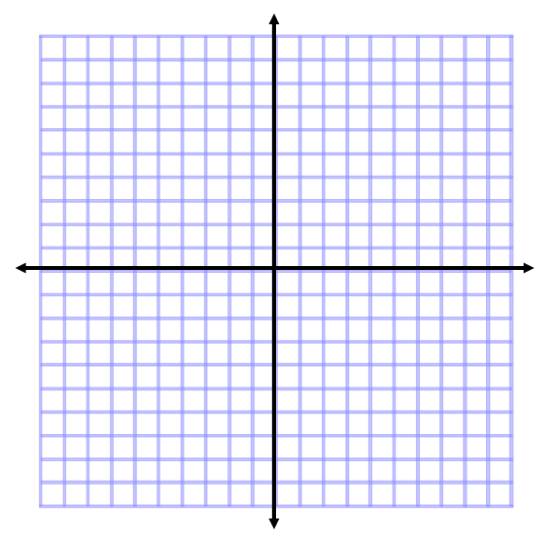

Key Concepts

__________________ - a set of pairs of input and output values.

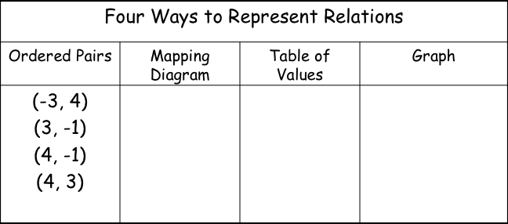

Examples
- When skydivers jump out of an airplane, they experience free fall. At 0 seconds, they are at 10,000ft, 8 seconds, they are at 8976ft, 12 seconds, they are at 7696ft, and 16 seconds, they are at 5904ft. How can you represent this relation in four different ways?

Key Concepts

_______________ - the set of all inputs (x-coordinates)
_______________ - the set of all outputs (y-coordinates)
________________________ - a relation in which each element in the domain corresponds to exactly one element of the range.
________________________________ - if any vertical line passes through more than one point on the graph of a relation, then it is not a function.

Examples
- Determine whether each relation is a function. State the domain and range.
a) {(0, 1), (1, 0), (2, 1), (3, 1), (4, 2)} b) {(1, 4), (3, 2), (5, 2), (1, -8), (6, 7)}

c) {(1, 3), (2, 3), (3, 3), (4, 3), (5, 3)} d) {(4, 9), (4, 3), (4, 0), (4, 4), (4, 1)}

- Use the vertical line test. Which graphs represent a function?

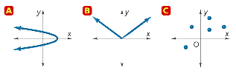

4. Create a relation that: a) is not a function b) is a function

Challenge/Early finishers do Think About a Plan task on page 30 for extra credit.

Exit ticket: Express the relation {(2,1), (3,2), (3, 4), (4, 7), (5, -1)} using mapping diagram and graph. Is this relation a function?
Standard: A2. F.BF.A.1 Write a function that describes a relationship between two quantities.
Objective: Students will evaluate functions and write the relationship between input and output using ordered pairs, and create functions to describe real life problems.

Section 2.1 Part 2: Relations and Functions

Warm Up

1. Can you have a relation that is not a function? If yes, give an example.

2. Can you have a function that is not a relation? If yes, give an example.

Key Concepts
________________________________ - an equation that represents an output value in terms of an input value. You can write the function rule in function notation.
_________________________________ - x, represents the input value.
______________________________ - y, represents the output value. (Call dependent because it depends on the input value)

Examples
- Evaluate the function for the given value of x, and write the input x and output f (x) in an ordered pair.
f (x) = −2x + 11 for x = 5, -3, and 0

- Write a function rule to model the cost per month of a long-distance cell phone calling plan. Then evaluate the function for given time the cellphone is used.

Monthly service fee: $4.99
Rate per minute: $.10
Time used: 2.5 hours

White board activity #1-4 page 29

Challenge/Early finishers do #5 for extra credit.

Exit ticket: Create three coordinate points given the function f(x)= -5x+1 and the x values -4, -2 and 0

Standards: A2.F.BF.A.1 Write a function that describes a relationship between two quantities.A2.F.BF.A.1a Determine an explicit expression, a recursive process, or steps for calculation from a context.

Objective: Students will be able to graph linear equations. Students will be able to write equations of line in y intercept form.

2.3: Linear Functions and Slope-Intercept Form

Warm Up
Evaluate each expression for x = –2, and 0.
1. f(x) = 2x + 7 2. f(x) = 3x – 2

Key Concepts
________________ - the rate of change

POSITIVE NEGATIVE ZERO UNDEFINED
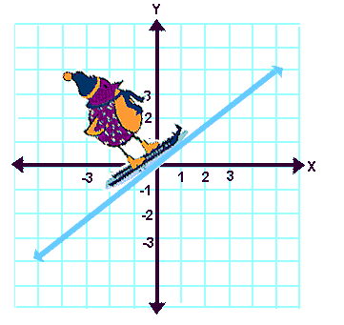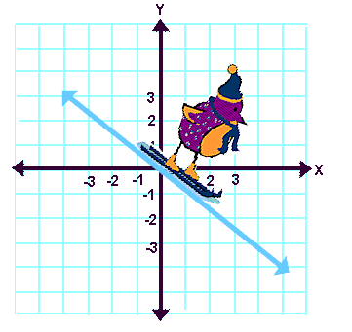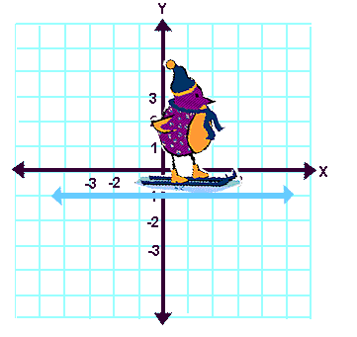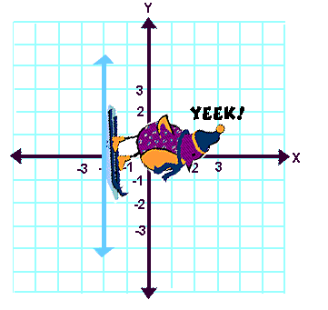

_______________________- a function whose graph is a line

_______________________ - represents a linear function where a solution is any ordered pair (x,y) that makes the equation true.

____________________________ - the point in which a line crosses the y-axis

Any number of a form (0,n) is a y intercept

____________________________ - the point in which a line crosses the x-axis

Any number of a form (n,0) is a x intercept

Slope Intercept Form

y = mx + b m = slope; b= y-intercept

Examples
- Find the slope of the line through the points:
a. (3, 0) and (5, 8) b. (1, –4) and (2, –5) c. (–2, 7) and (8, –6)

- What is an equation of the line that has a slope of 1/5 and the y-intercept is (0, -3)?

- Write the equation in slope-intercept form and then find the slope and y-intercept of
–7x + 2y = 8.

- Graph the equation y = 2x + 1. 5. Graph the equation y= -3/2 +4

6. Graph the equation y= 5x 7. Graph the equation y=-1/2 x -3

White board activity #1-5 page 37

Challenge/Early finishers do #6 for extra credit.

Exit ticket: Graph y = -3/4x +5
Objectives: Students will be able to create and graph linear functions in all three forms:
y- intercept, point slope and standard form. Students will be able to create functions parallel or perpendicular to some given lines.
Standards:
A2.F.BF.A.1 Write a function that describes a relationship between two quantities.
A2.F.BF.A.1a Determine an explicit expression, a recursive process, or steps for calculation from a context.
A2.F.BF.A.1b Combine standard function types using arithmetic operations.
2-4 More Linear Functions
Warm up
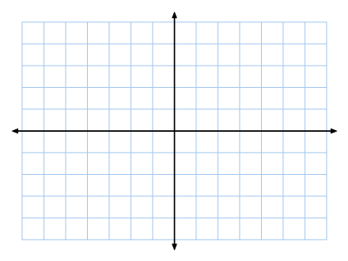
Graph a function -2x + 3y = 6. Write it in y-intercept form then graph.

Vocabulary
______________________ - the slopes of these lines are equal.
_____________________________ - the slopes of these lines are negative reciprocals of each other.
Examples of negative reciprocals : 1/3 _____ -2/3 ______ -1 ______ 5 ______
Formulas
- point-slope form of a line is $y-y_{1}=m(x{-x}_{1})$
- standard form of a linear equation is $Ax+By=C$
- m =$-\frac{A}{B}$, y-intercept = $\frac{C}{B}$, x-intercept = $\frac{C}{A}$
Examples
- Write the equation of the line that passes through (-6, 2) with a slope of $\frac{2}{3}$.
a) y-intercept form b) point slope form c) standard form

- Write the equation of the line through (-3, 2) and (5, 8).
a) y-intercept form b) point slope form c) standard form

- Write the equation $y= \frac{3}{4}x-5$ in standard form. Use integer coefficients.

- What is the equation of the line in point-slope form?

- Find the x- and y-intercepts of $2x+3y=-12$.

- What is the equation of the line parallel to $y=2x-3$ through (1, -3) in slope-intercept form?

- What is the equation of the line perpendicular to $y= \frac{2}{3}x-1$ through (-2, 4) in slope-intercept form?

HOMEWORK!!! Complete your assignment on a separate sheet of paper. Show all Work
- Write an equation for each line in slope-intercept form
- slope = -3, through (1, -4) b. slope = $\frac{1}{2}$ , through (2, 3)

- What are the intercepts of $3x+y=6$? Graph the equation.

- If the intercepts of a line are (a, 0) and (0, b), what is the slope of the line?

- Write the equation of the line through (1, 9) and (6, 2) in point-slope form?

- Write an equation of each line in standard form with integer coefficients.
- $y=-7x-9$ b. $y=-\frac{3}{5}x+3$
- Write an equation for the line shown in standard form.

Standard: A2.A.REI.D.6 (formerly A.REI.11) Explain why the x-coordinates of the points where the graphs of the equations y = f(x) and y = g(x) intersect are the solutions of the equation f(x) = g(x); find the approximate solutions using technology. ★Include cases where f(x) and/or g(x) are linear, polynomial, rational, absolute value, exponential, and logarithmic functions.

Objectives; Students will graph and find solutions of absolute value functions using a variety of strategies. The students will apply translations, stretches, compressions, and reflections to the absolute value function
2.7: Absolute Value Functions and Graphs
Students will be able to graph absolute value functions

Warm Up
Solve each absolute value equation.

Key Concepts
Graph of Absolute Value Function

_________________________ - the line that divides a figure into two parts that are mirror images
__________ - a point where the function reaches a maximum or minimum value

Guided practice
- Graph the absolute value functions:

a) y = |x| - 4 b) y= |x-3| c) y= -2|x|
Summary
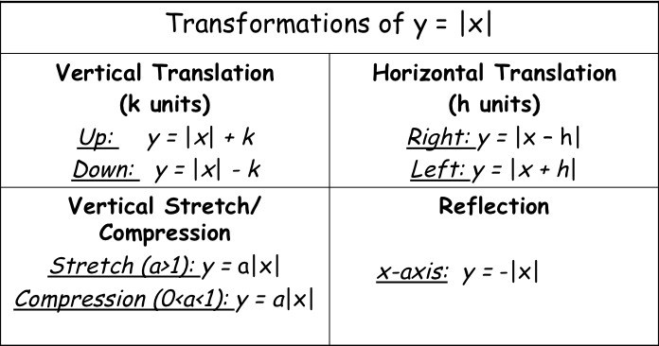

Group practice
- Graph each absolute value function.
a. y = |x + 2| + 3 b. y = 1/2|x|

Key Concepts

General Form of the Absolute Value Function

y = a |x-h| + k

Stretch/Compression Factor is |a|, Vertex is (h, k), Axis of Symmetry is x = h

Examples
- Without graphing, identify the vertex, axis of symmetry, and transformations of
f(x) = -3|x – 1| + 4 from the parent function f(x) = |x|.

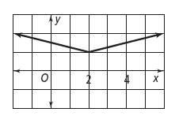
- Write an absolute value equation for the given graph.

White board activity #1-3 page 53

Challenge/Early finishers do #4 for extra credit.

Exit ticket: Graph = |x + 1|- 3

