Homework 6-6: Complete your assignment on a separate sheet of paper. Show all work.
1. Let 𝑓(𝑥)=𝑥−2 and 𝑔(𝑥)= 𝑥²−3𝑥+2. Find each of the following and state the domain.
a. Find 𝑓+𝑔
b. Find 𝑓−𝑔
c. Find 𝑓∙𝑔
d. Find 𝑓/𝑔
e. Find 𝑓∘𝑔
f. Find 𝑔∘𝑓

2. A car dealer offers a 15% discount of the list price x of any car on the lot. At the same time, the manufacturer offers a $1000 rebate for each purchase of a car.

a. Write a function f(x) to represent the price after discount.
b. Write a function g(x) to represent the price after the $1000 rebate.
c. Suppose the list price of a car is $18,000. Use a composite function to find the price of the car if the discount is applied before the rebate.
d. Suppose the list price of a car is $18,000. Use a composite function to find the price of the car if the discount is applied after the rebate.
e. Reasoning Between parts (c) and (d), will the dealer want to apply the discount before or after the rebate? Why?

Homework 6-7: Complete your assignment on a separate sheet of paper. Show all work.

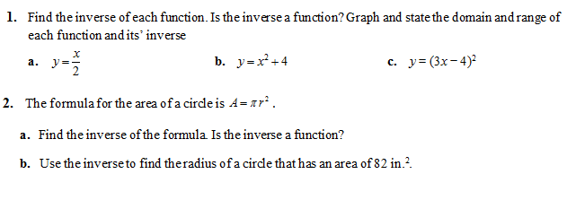
Homework 6-8: Complete your assignment on a separate sheet of paper. Show all work.
